**Will Barlow 81776940**

**COSC 328 Lab01**

**Transmission (20 marks)**

Complete the following review questions from the text:

1. R18. How long does it take a packet of length 1,000 bytes to propagate over a link of distance 2,500 km, propagation speed 2.5 x 108 m/s, and transmission rate 2 Mbps? More generally, how long does it take a packet of length L to propagate over a link of distance d, propagation speed s, and transmission rate R bps? Does this delay depend on packet length? Does this delay depend on transmission rate? (10 marks)

dPropagation = .01s

dTransmission = .0005s

Time for Packet L to propagate distance d, speed s, at rate R = L/R + d/s

Yes, the delay depends on the transmission rate.

1. R19. Suppose Host A wants to send a large file to Host B. The path from Host A to Host B has three links, of rates R1 = 500 kbps, R2 = 2 Mbps, and R3 = 1 Mbps. (10 marks)
2. Assuming no other traffic in the network, what is the throughput for the file transfer?

2Mbps

1. Suppose the file is 4 million bytes. Dividing the file size by the throughput, roughly how long will it take to transfer the file to Host B?
2. 2 seconds
3. Repeat (a) and (b), but now with R2 reduced to 100 kbps.

4 seconds

**Packet Switching (10 marks)**

1. For this question, let the packet size L = 1000 bytes, the propagation speed s = 2.5 x 108 m/s, the link distance d = 2000 km, and the transmission rate R = 10 Mbps (megabits per second). Assume that 1 Mbyte (megabyte) = 1 x 106 bytes (SI definition). Be mindful of units. Answer these questions:
   1. Write the formula and calculate the propagation delay for a packet on the link.

.008 seconds

* 1. Write the formula and calculate the transmission delay for a packet on the link.

.0001 seconds

* 1. Ignoring queuing and processing delays, what is the total end-to-end delay if two hosts are connected by 3 links (2 routers) of this type. Assume all links have the same transmission rate and propagation speed, but the links have lengths of 10 m, 1000 km, and 5000 km respectively.

.0241004 seconds

**Packet vs. Circuit Switching (20 marks)**

1. P8. Suppose users share a 3 Mbps link. Also suppose each user requires 150 kbps when transmitting, but each user transmits only 10 percent of the time. (See the discussion of packet switching versus circuit switching in Section 1.3.)
   1. When circuit switching is used, how many users can be supported? (2.5marks)

20 users

* 1. For the remainder of this problem, suppose packet switching is used. Find the probability that a given user is transmitting. (2.5 marks)

10%

1. For this question, let the packet size L = 1000 bytes, the propagation speed s = 2.5 x 108 m/s, the link distance d = 2000 km, and the transmission rate R = 10 Mbps. For circuit switching, the setup time is 5 ms, and each link supports 10 circuits. One of the factors that needs to be considered is the setup time for the circuit (being the time for each switch to connect the correct inbound and outbound circuits). In this case the setup time provided is for the complete circuit to be formed and can be included in the total delay as a single factor. Assume that 1 Mbyte (megabyte) = 1 x 106 bytes (SI definition). Be mindful of units. Answer these questions: (10 marks)
   1. How many simultaneous users can be on one link in a circuit switched network?

Only 20

* 1. Assume we have 3 switches connected in a triangle. What is the maximum number of connections supported on this network with circuit-switching (keeping in mind that that each link supports a limited number of circuits, whereas the switches are limited only by the total number of available links)?

30

* 1. Given a file size of 1 MB, how long does it take to send it from one host to another over 4 circuit switched links?

.452 seconds

* 1. Given the same file of 1 MB, how long does it take to send it between two hosts that are connected with 4 datagram, packet switched links where the switches use store-and-forward? In a packet switched network, data needs to be encapsulated (information regarding addressing) needs to be added. Assume each packet has a header size of 50 bytes in addition to its data payload of 1000 bytes.

.324315 seconds

* 1. How long does it take to transfer the 1 MB file if store-and-forward is not used (assume that packet can flow through the switch without delay)?

.108105 seconds

**Queuing Delay (10 marks)**

1. For this question, let the packet size L = 1000 bytes, the propagation speed s = 2.5 x 108 m/s, the link distance d = 2000 km, and the transmission rate R = 10 Mbps. Assume that 1 Mbyte (megabyte) = 1 x 106 bytes (SI definition). Answer these questions:
   1. If 5 packets arrive simultaneously and the queue is initially empty, what is the average queuing delay for all 5 packets.

.0405 seconds

**Transmission Times (10 marks)**

1. P24. Suppose you would like to urgently deliver 40 terabytes data from Boston to Los Angeles. You have available a 100 Mbps dedicated link for data transfer. Would you prefer to transmit the data via this link or instead use FedEx overnight delivery? Explain:

It would take 40.01 seconds to send 40 terabytes of data from Boston to Los Angeles on a dedicated 100 Mbps data link. Given this time, I would prefer to transmit the data via this link instead of FedEx overnight delivery because it would be faster and I wouldn’t have to risk losing it.

**Layers and services (20 marks)**

1. R22. List five tasks that a layer can perform. Is it possible that one (or more) of these tasks could be performed by two (or more) layers? (10 marks)
   * 1. Contain a message (application)
     2. Transport a message (transport)
     3. Move datagrams between hosts (network)
     4. Passes datagram to network (link)
     5. Moves individual bits from node to node (physical)

It is possible for one or more of these tasks to be performed by two or more layers.

1. R25. Which layers in the Internet protocol stack does a router process? Which layers does a link-layer switch process? Which layers does a host process? (10 marks)

Router: network, link, and physical

Switch: link and physical

Host: all

1. From your computer (either a lab machine or your own), open up a terminal (Command prompt on Windows, or terminal on Linux/OS X) and perform a Traceroute to google.ca. Answer the following questions: (10 marks)
   1. Copy and paste the output of your Traceroute into your assignment.

Tracing route to google.ca [172.217.1.3]

over a maximum of 30 hops:

1 3 ms 2 ms 1 ms 192.168.0.1

2 11 ms 14 ms 10 ms 174.4.96.1

3 23 ms 22 ms 24 ms rd3cs-be101-1.ok.shawcable.net [64.59.170.105]

4 13 ms 13 ms 14 ms rc1st-tge0-5-0-14.vc.shawcable.net [66.163.72.225]

5 25 ms 20 ms 20 ms 209.90.173.177.gs.unused.primus.ca [209.90.173.177]

6 23 ms 20 ms 19 ms 209.90.160.3

7 20 ms 22 ms 20 ms 10.201.119.214

8 21 ms 20 ms 22 ms 10.201.119.210

9 20 ms 32 ms 20 ms 64.124.33.18

10 26 ms 25 ms 33 ms ae11.cs1.sea1.us.eth.zayo.com [64.125.23.40]

11 34 ms 26 ms 23 ms ae27.mpr1.sea1.us.zip.zayo.com [64.125.29.1]

12 26 ms 24 ms 28 ms 72.14.208.172

13 27 ms 24 ms 26 ms 74.125.243.194

14 32 ms 32 ms 32 ms 142.250.228.150

15 74 ms 72 ms 71 ms 142.250.231.200

16 73 ms 72 ms 75 ms 142.251.67.141

17 81 ms 80 ms 79 ms 172.253.76.221

18 80 ms 80 ms 85 ms 108.170.250.241

19 84 ms 87 ms 88 ms 216.239.35.233

20 81 ms 79 ms 81 ms yyz10s14-in-f3.1e100.net [172.217.1.3]

Trace complete.

b. Using the provided URL for the geolocation tool, determine the postal code/zip code for each hop in the route as well as the ISP responsible for the router and list in a table in proper order.

|  |  |  |  |
| --- | --- | --- | --- |
| Hop | Postal Code | City | ISP |
| 1 | Private | Private | Private |
| 2 | V1x7J2 | Kelowna | Shaw Communications |
| 3 | V1Y7X1 | Kelowna | Shaw Communications |
| 4 | R2K0A1 | Winnipeg | Shaw Communications |
| 5 | L4W5L6 | Mississauga | Primus Telecom |
| 6 | T8A0A1 | Sherwood Park | Primus Telecom |
| 7 | Private | Private | Private |
| 8 | Private | Private | Private |
| 9 | 55432 | Minneapolis | Zayo Bandwidth |
| 10 | 98115 | Seattle | Zayo Bandwidth |
| 11 | 98115 | Seattle | Zayo Bandwidth |
| 12 | 94043 | Mountain View | Google Inc. |
| 13 | 94043 | Mountain View | Google Inc. |
| 14 | 94043 | Mountain View | Google Inc. |
| 15 | 94043 | Mountain View | Google Inc. |
| 16 | 94043 | Mountain View | Google Inc. |
| 17 | 94043 | Mountain View | Google Inc. |
| 18 | 94043 | Mountain View | Google Inc. |
| 19 | 94043 | Mountain View | Google Inc. |
| 20 | 94043 | Mountain View | Google Inc. |

c. Using Google Maps (or equivalent), plot and number the hops based on postal codes/zip codes for each router in the path. Submit a copy of your map with your assignment.

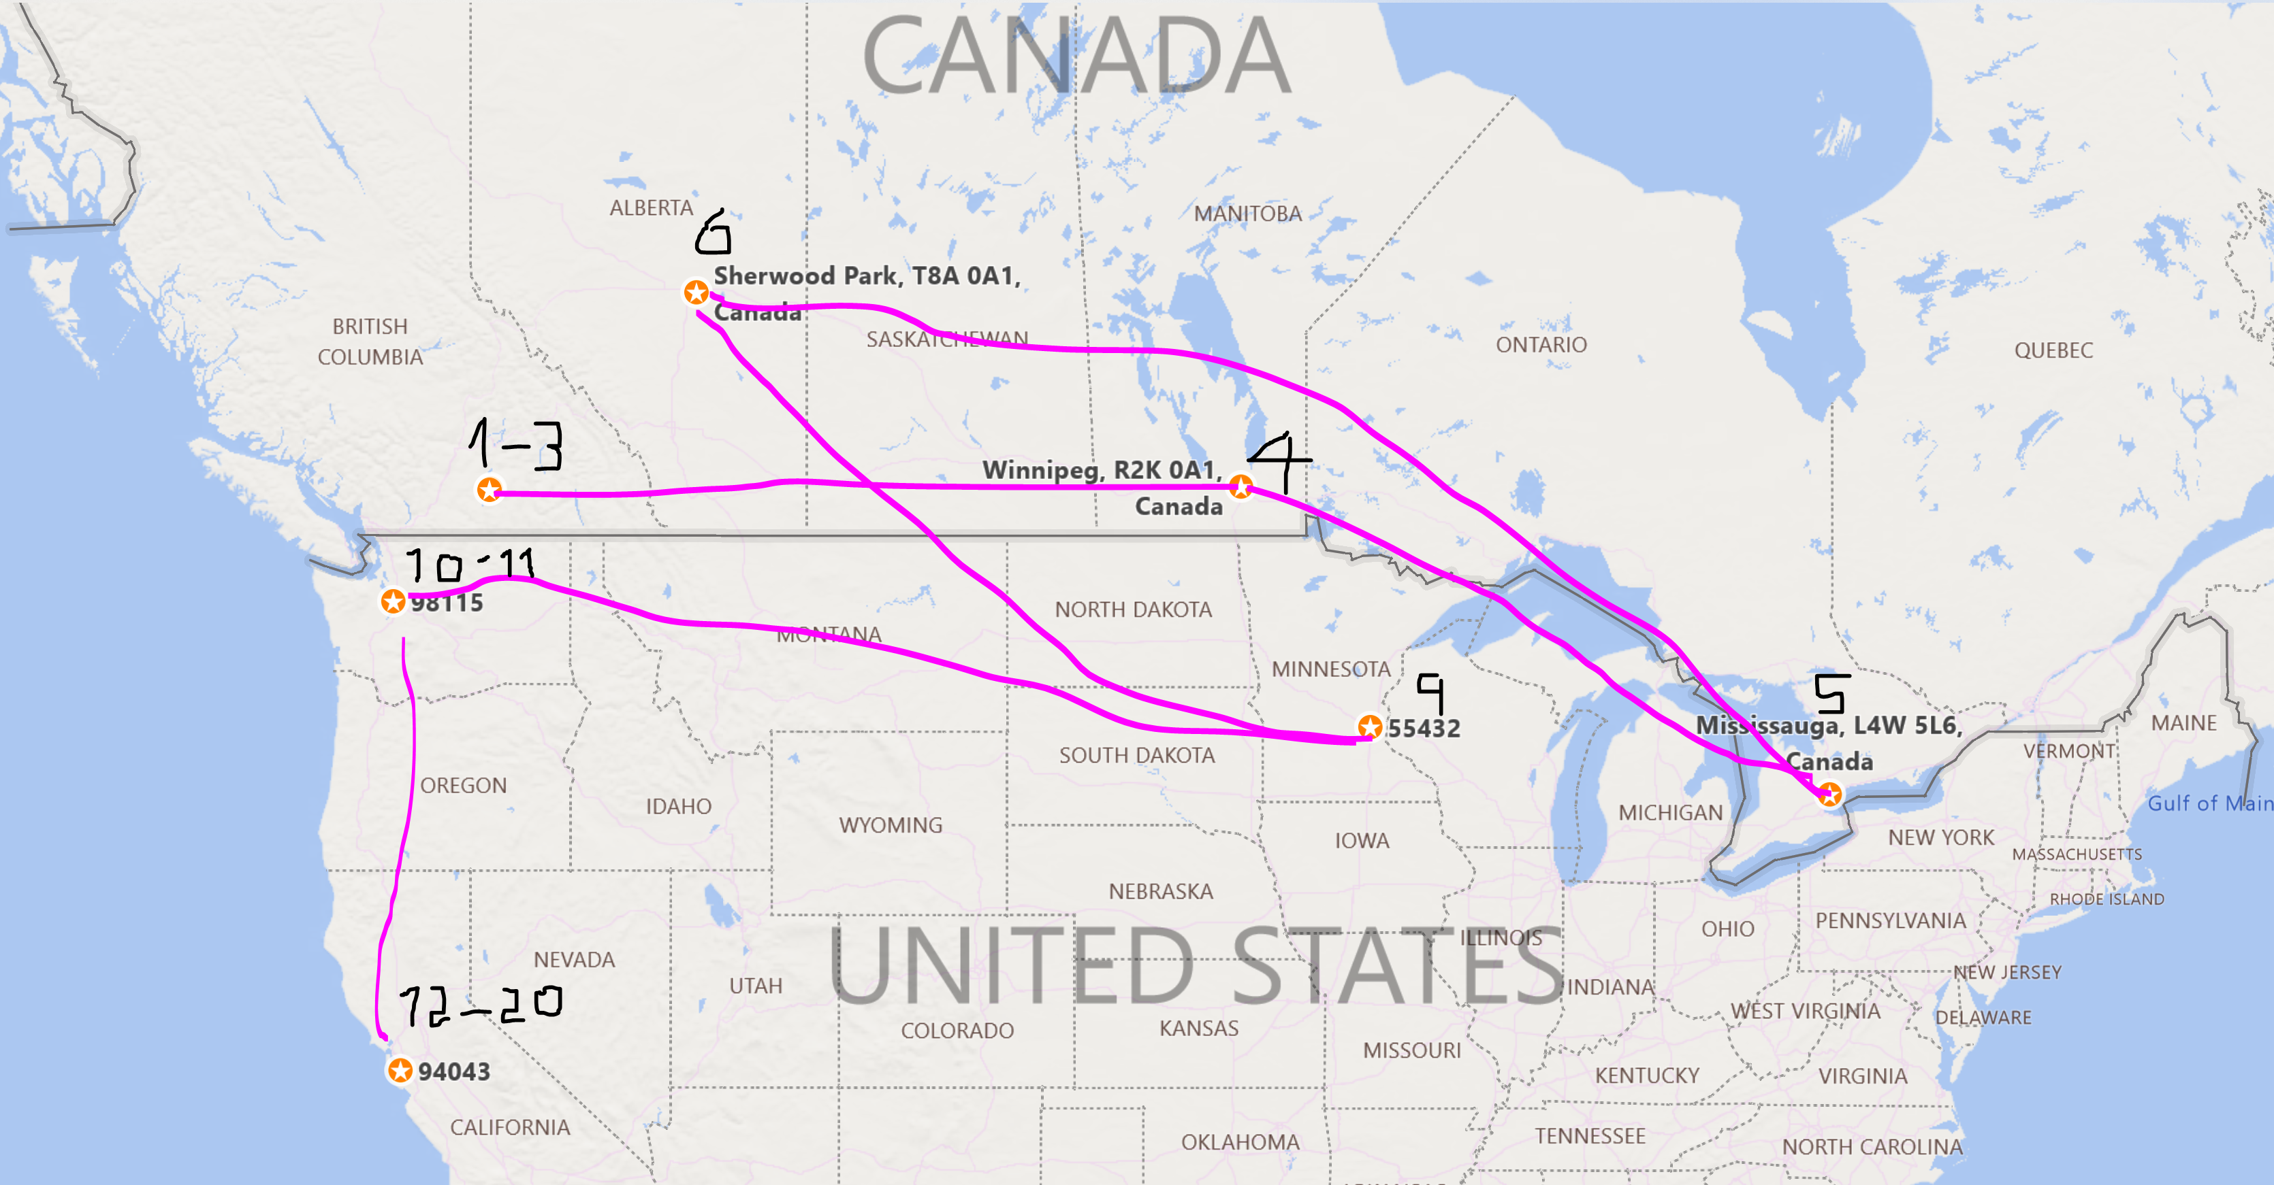

d. Once your map is complete, consider the complexity of the route taken to reach this destination. Considering the approximate length of the route (which can be done with a straight-line approximation of the distance measure between points and using the propagation speed s = 2.5 x 10^8 m/s), does the round-trip time seem reasonable and what are the other factors that can impact this time? Remember that this is a round-trip time, so to consider the time is takes to go from source to destination, divide the time in half.

1. 1-3 to 4 (d1): 975.8 mi = 1570398 m
   1. Delay = .006281592 s
2. 4 to 5 (d2): 918.2 mi = 1477700 m
   1. .0059108
3. 5 to 6 (d3): 1693 mi = 2724619 m
   1. .010898476
4. 6 to 9 (d4): 1076.3 mi = 1732137 m
   1. .006928548
5. 9 to 10-11 (d5): 1415.9 mi = 2278670 m
   1. .00911468
6. 10-11 to 12-20 (d6): 697.1 mi = 1121874 m
   1. .004487496
7. 12-20 to start (d7): 857.9 mi = 1380656 m
   1. .005522624
8. Total delay = .049144216 s
9. Delay from origin to destination direct = .011045248 s

Total distance: 12,286,054 m

Distance from origin to destination: 2,761,312 m

The time can certainly be decreased with a more direct connection to the destination server. However, the difference is most likely imperceptible.

